CS 255 System Design Document Template

Jessica Vazquez
April 15, 2026

UML Diagrams

UML Use Case Diagram
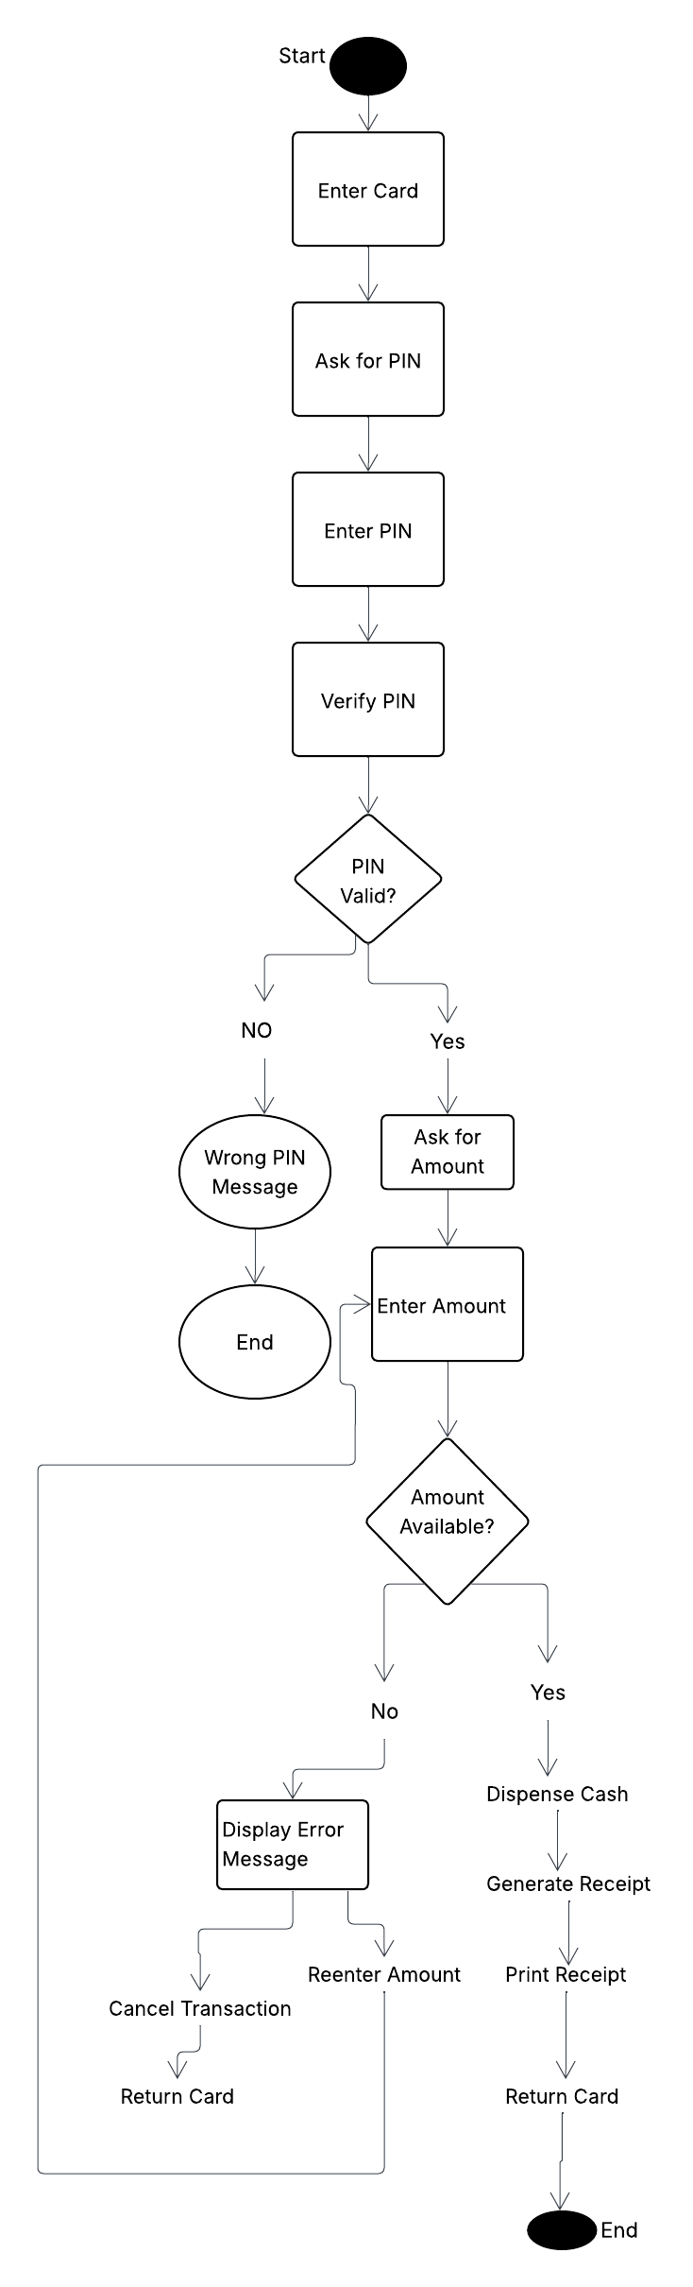 Figure 1: Use Case Diagram

UML Activity Diagrams
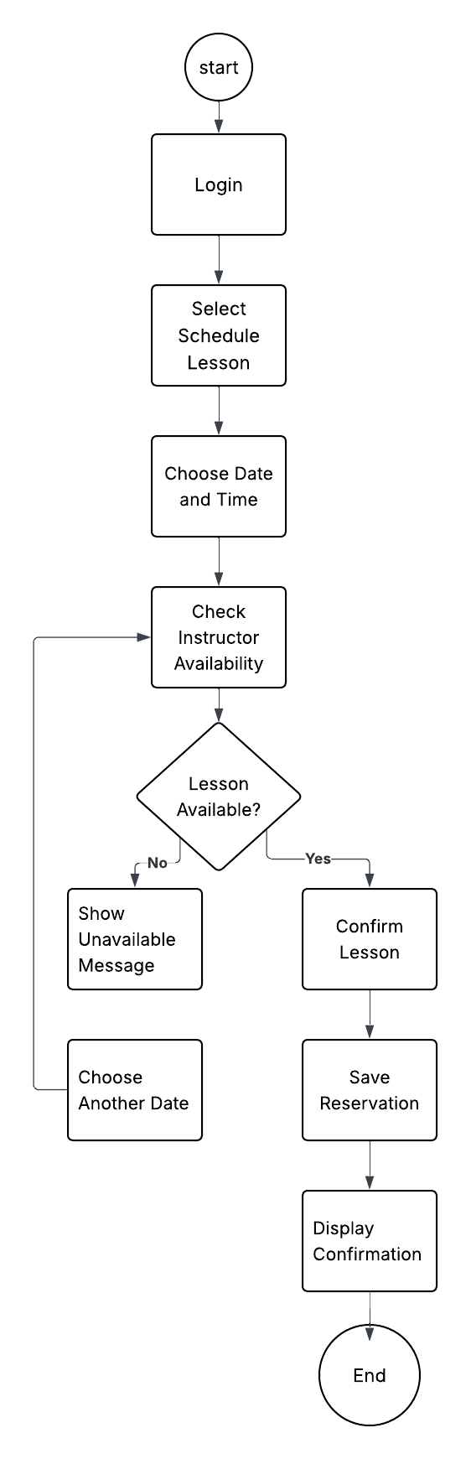Figure 2: Activity Diagram – Schedule Driving Lesson
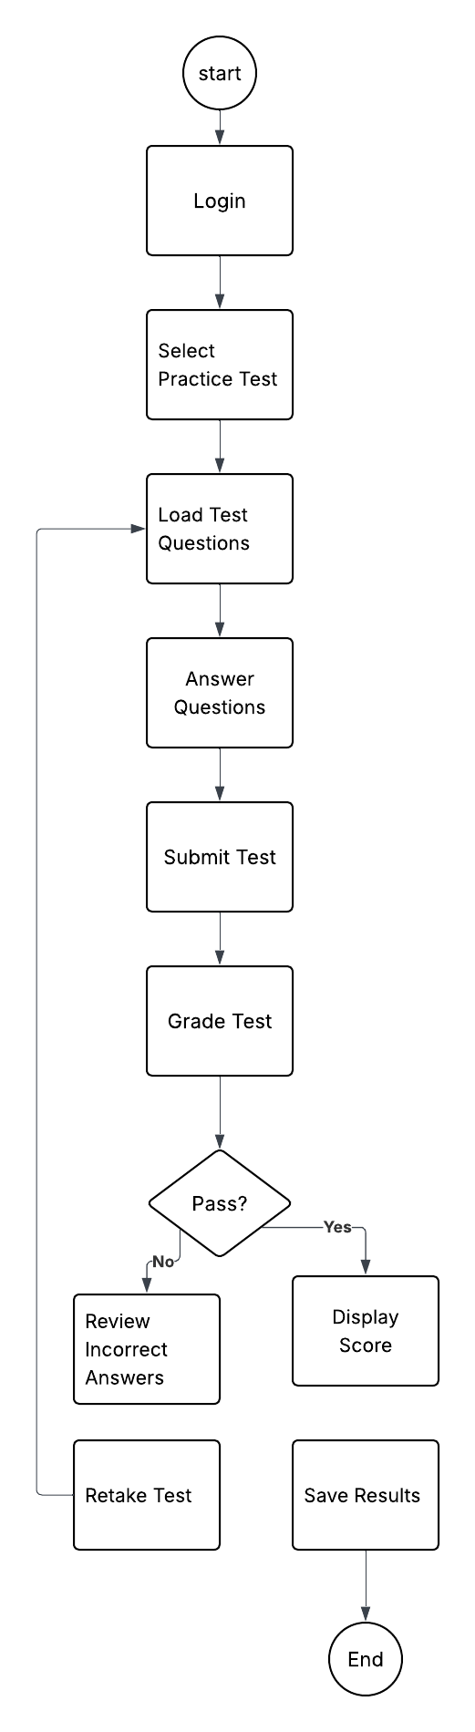Figure 3: Activity Diagram – Take Practice Test

UML Sequence Diagram

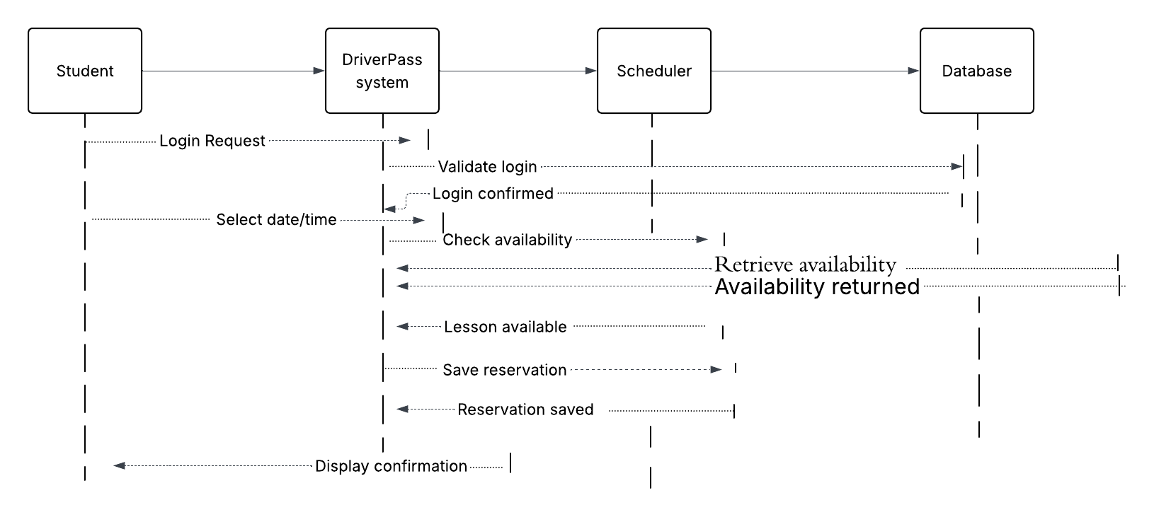

Figure 4: Sequence Diagram – Schedule Driving Lesson

UML Class Diagram

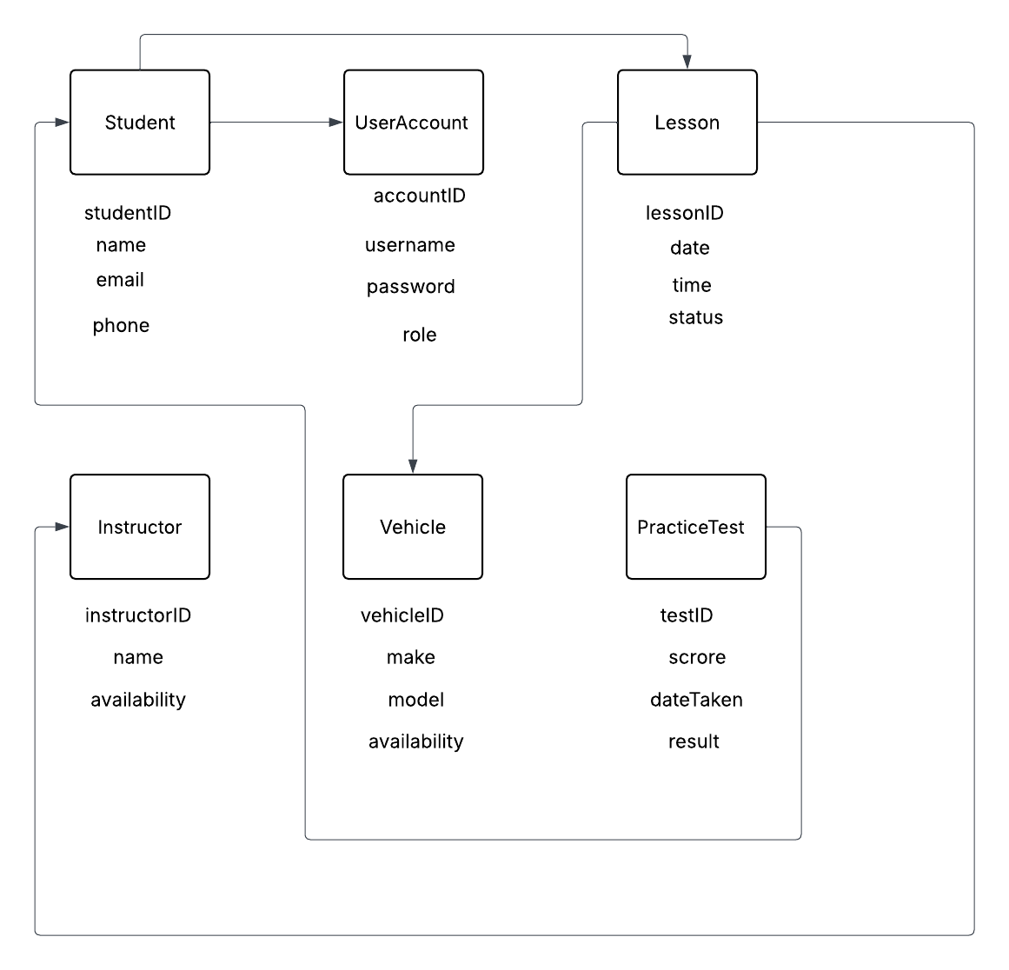Figure 5: Class Diagram

Technical Requirements

The DriverPass system will be a web-based application that allows users to access it from any device with internet access.

The system requires hardware such as computers, tablets, or mobile devices for users, as well as secure servers to store system data. These servers will handle user accounts, scheduling information, and practice test results.

The software requirements include a web browser such as Google Chrome or Microsoft Edge, a database management system to store user and lesson data, and backend software to manage scheduling, testing, and overall system functionality.

The system will use cloud-based infrastructure to ensure reliability, scalability, and data security. This allows the system to handle multiple users at the same time and store data safely.

Additional tools may include development environments, version control systems, and security features such as user authentication and data encryption to protect sensitive information.

